**EXPERINMENT 6**

**Aim :** To study various types of noises and implementation of it.

* **Exercises :**

1. **Synthesize the image of a chess board. (use intensity 50 for dark**

**block and 170 for bright block). Add gamma noise and exponential**

**noise (both separately) and generate noisy image. Show and**

**comment on histogram of the noisy images.**

* **Solution :-**

Code :

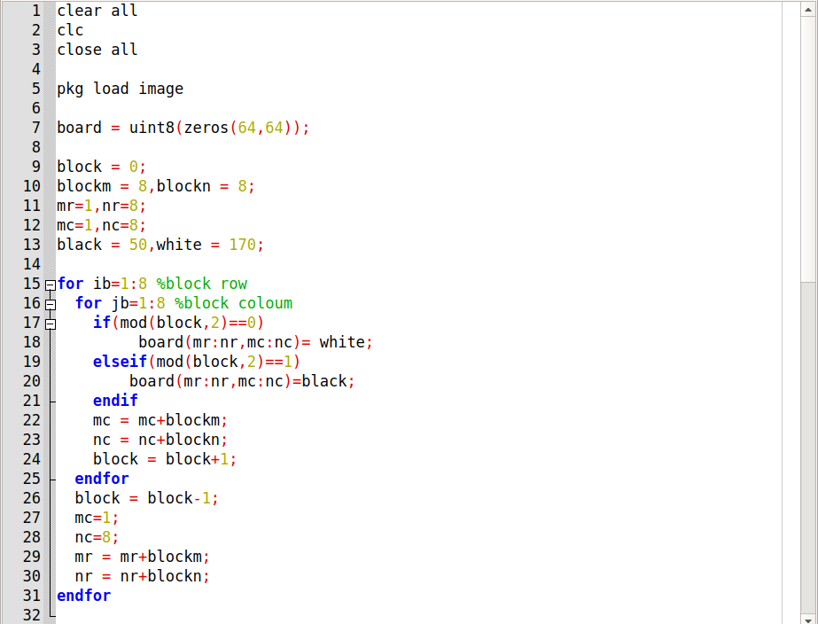

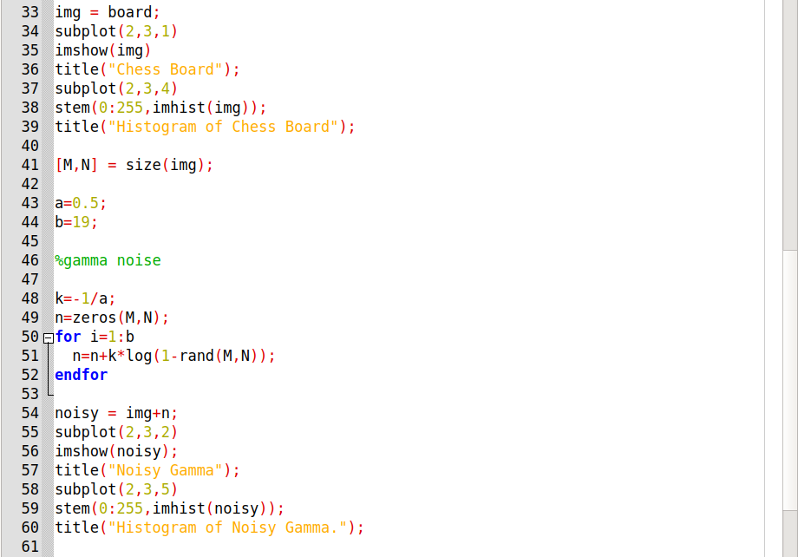

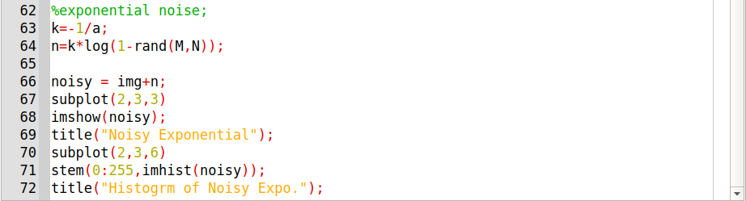

Output :

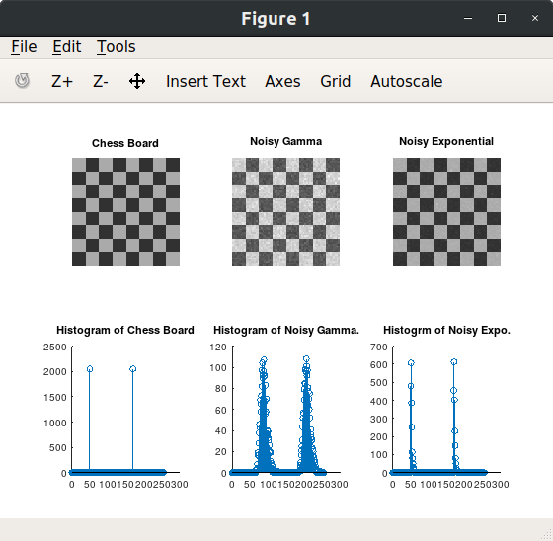

1. **Take your gray scale photo and generate noisy photo with:**
2. **Gaussian noise with probability 0.4 using randn function**

Code :

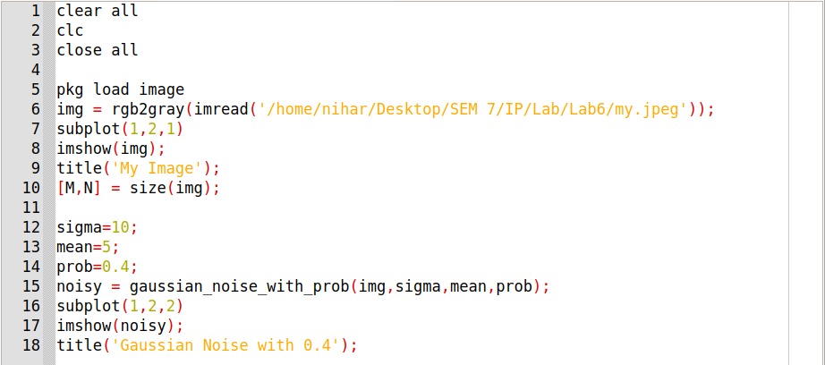

Function for Gaussian Noise with Probability :

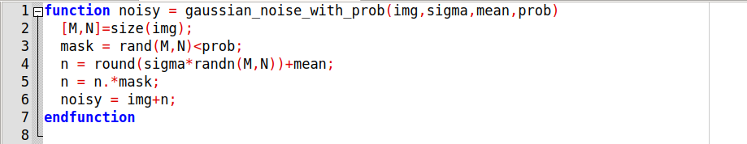

Output :

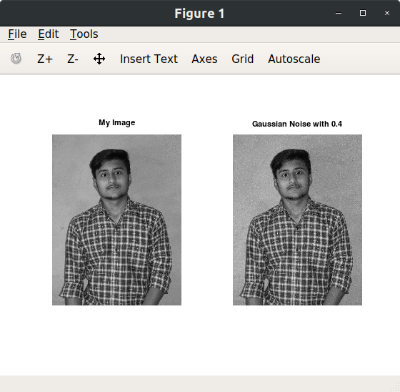

1. **Gaussian noise with mean 2 and variance 0.06 using imnoise function.**

Code :

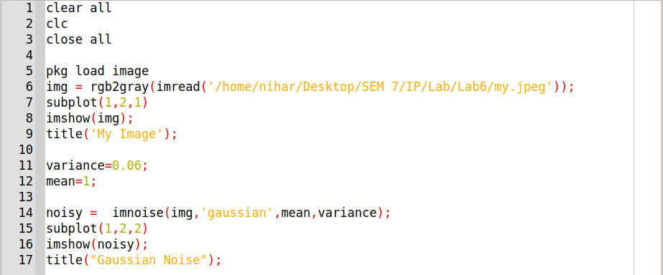

Output :

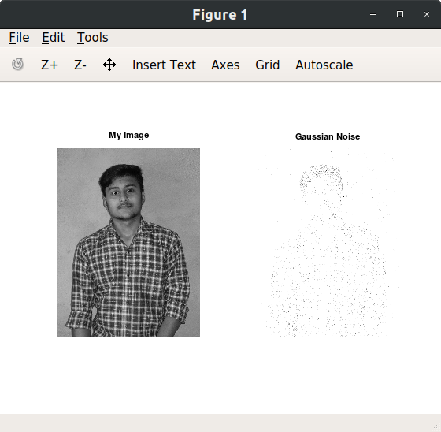

1. **Salt and pepper noise with probability 0.2 using your user defined function.**

Code :

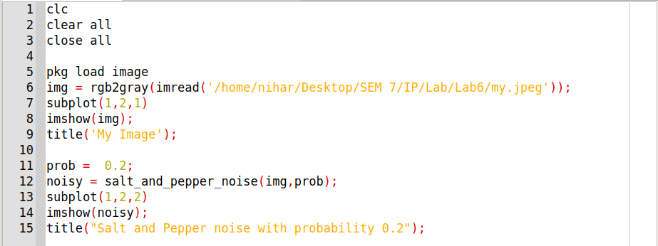

Function for Salt and Pepper Noise with Probability :

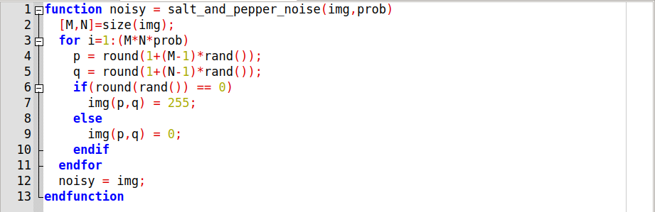

Output :

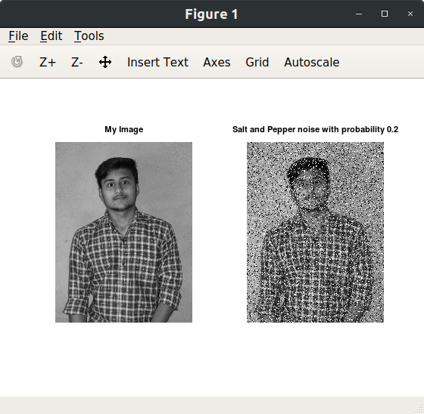

1. **Salt noise with probability 0.5 using your user defined function.**

Code :

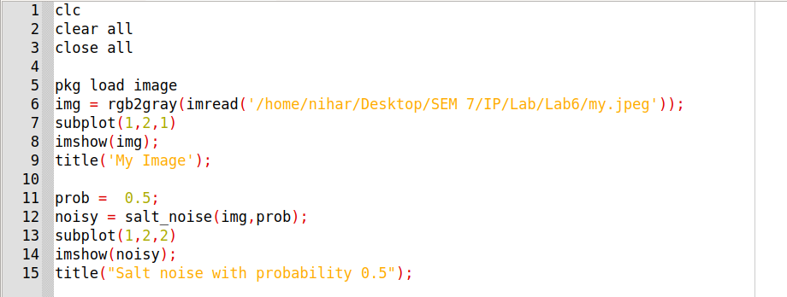

Function for Salt Noise with Probability :

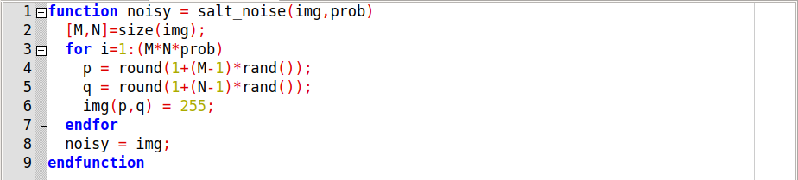

Output :

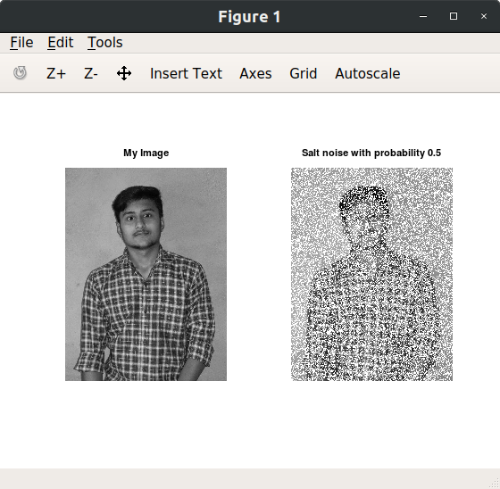

1. **Pepper noise with probability 0.3 using your user defined function.**

Code :

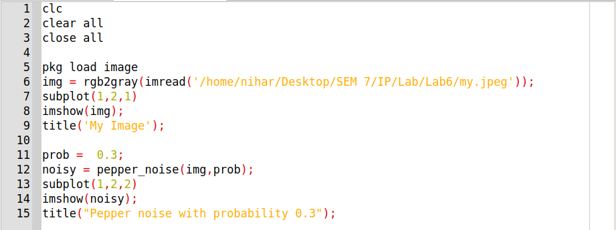

Function for Pepper Noise with Probability :

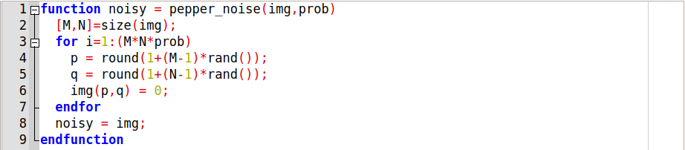

Output :

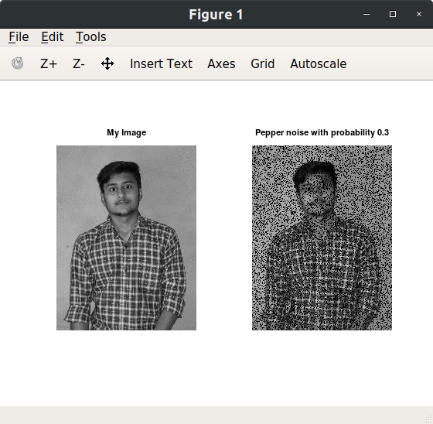

1. **Uniform noise with probability 1 and a=10 , b=20.**

Code :

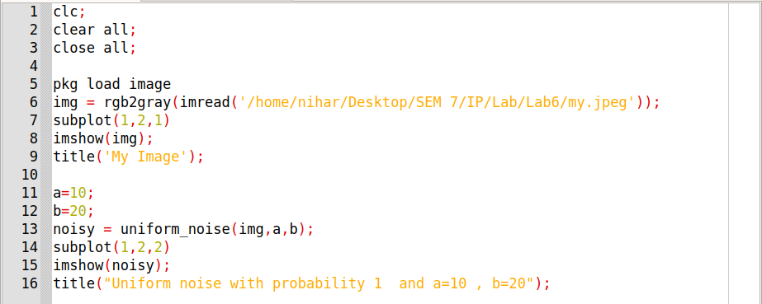

Function for Uniform Noise with Probability :

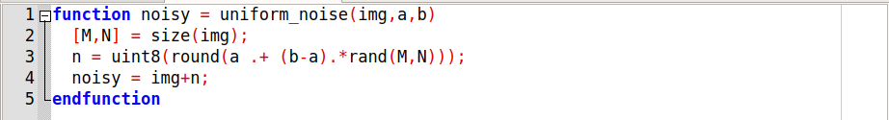

Output :

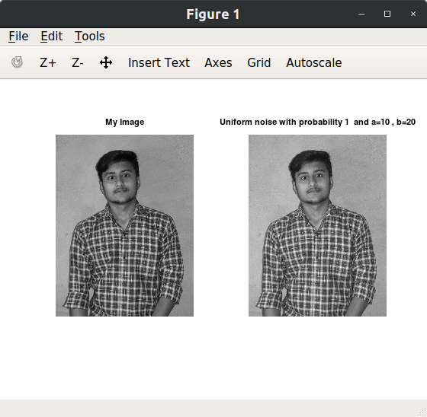

1. **Gaussian plus salt and pepper noise.**

Code :

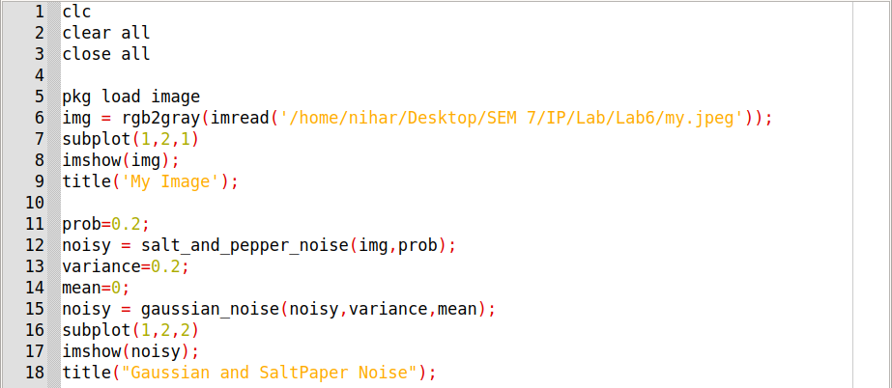

Output :

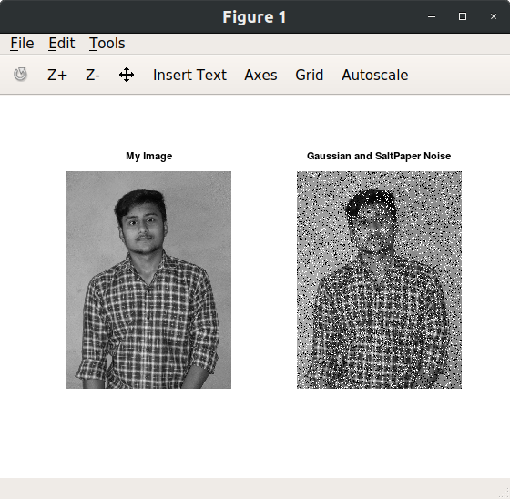

1. **Salt noise with probability 0.3 and pepper noise with probability 0.2 .**

Code :

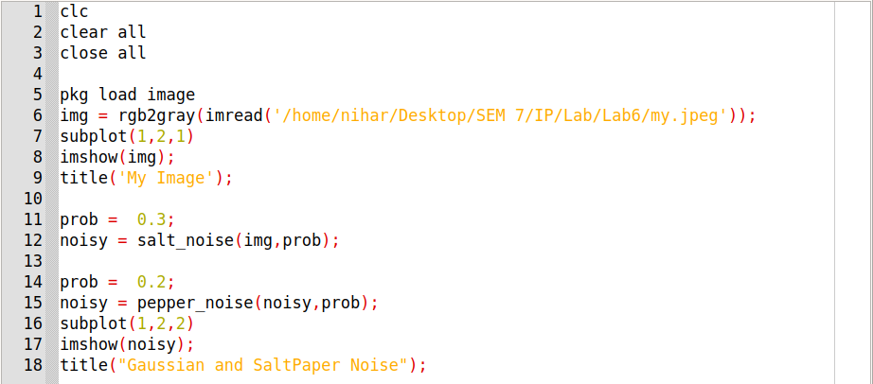

Output :

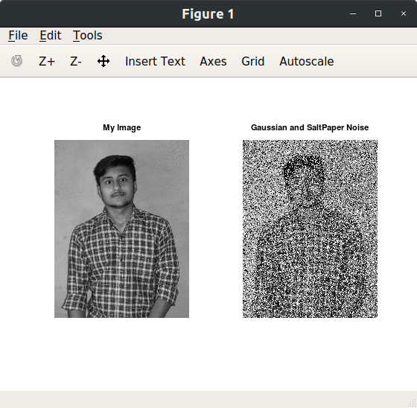

1. **Salt and pepper noise with random probability of salt and pepper noise.**

Code :

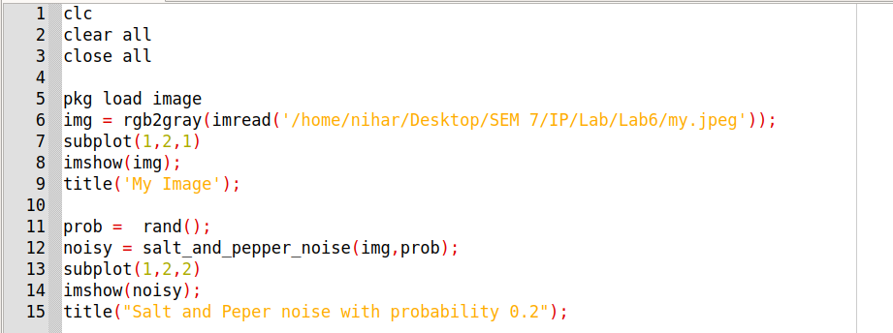

Output :

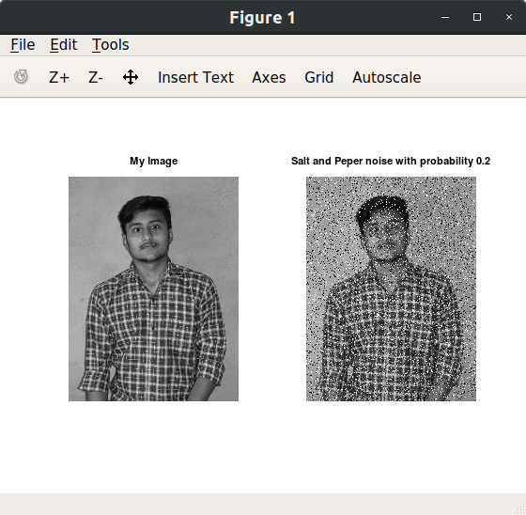

1. **Get information about imnoise and generate various noisy images.**

Code :

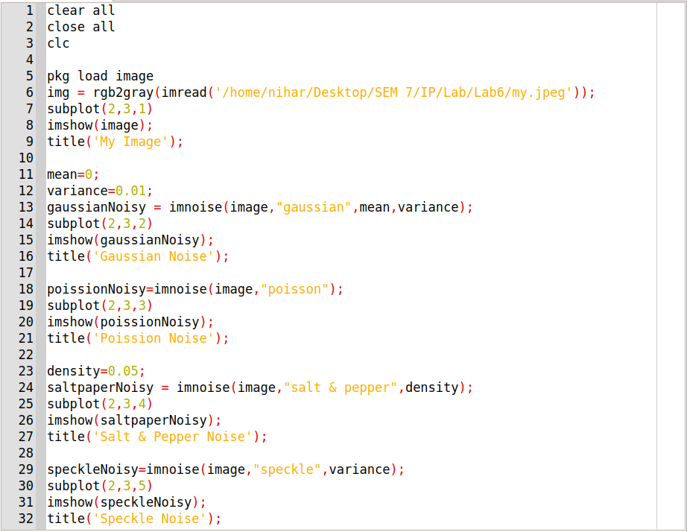

Output :

